Practical 3

**Aim** : Implementing character count using python and mapReduce

**Step 1:** Create a text file with some text and store it in some folder(Here we have stored it in charCount folder)

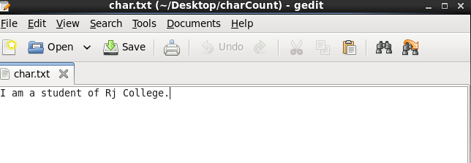

**Step 2 :** Create a mapper function in the same folder. Here we name the file as mapper.py

Code :

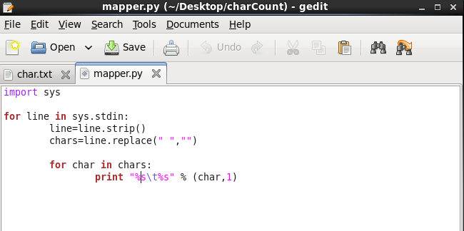

**Step 3 :** Create a reducer function in the same folder. Here we name the file as reducer.py

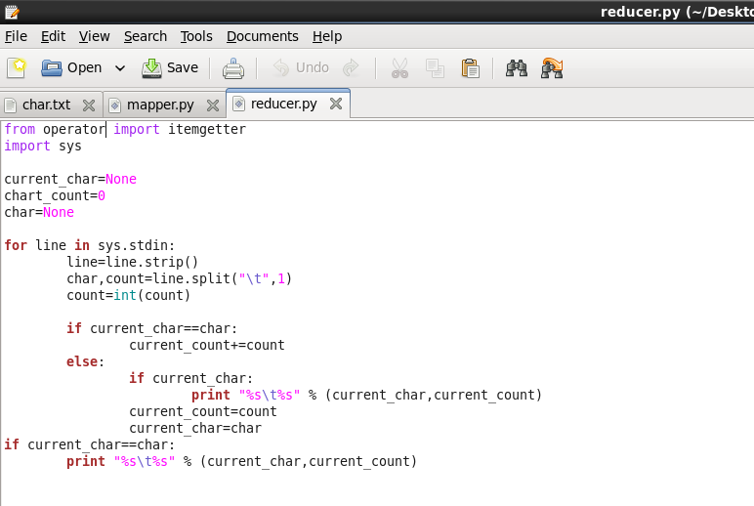

Step 4 : First we check our present working directory using “**pwd**” command.

Then we browse into the “**charCount**” folder by using **cd “location of the charCount folder”**

